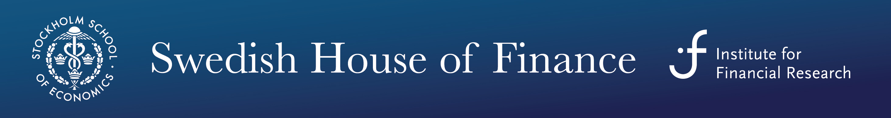
The Swedish House of Finance (SHoF) offers within its Doctoral Course Program in Finance a mini- course
Multifractal Analysis and Rare Events
with
Professor Laurent Calvet (HEC, Paris)

As the Great Financial Crisis reminds us, extreme movements in the level and volatility of asset prices are key features of financial markets. These phenomena are difficult to quantify using traditional approaches that specify extreme risk as a singular rare event detached from ordinary dynamics. Multifractal analysis, whose use in finance has considerably expanded over the past fifteen years, reveals that price series observed at different time horizons exhibit several major forms of scale-invariance. In this course, we will cover a new class of multifractal processes that permit the extrapolation from high-frequency to low-frequency events and generate accurate forecasts of asset volatility. The new models provide a structured framework for studying the likely size and price impact of events that are more extreme than the ones historically observed. Applications to currency, equity, fixed-income, and options markets will be discussed.

Schedule
- Tuesday, March 25 2014, 10.00-12.00 & 14.00-16.00 at SHoF, Drottninggatan 98
- Wednesday, March 26 2014, 09.30-11.30 & 14.00-16.00, at SHoF, Drottninggatan 98
- Thursday, March 27 2014, 09.30-11.30 & 14.00-16.00, at SHoF, Drottninggatan 98

Syllabus

*Calvet, L. E., and A. J. Fisher (2008). Multifractal Volatility: Theory, Forecasting and Pricing. Elsevier – Academic Press. [A book-length treatment of multifractal processes and their applications to currency and equity markets]

Calvet, L. E., and A. J. Fisher (2013). “Extreme Risk and Fractal Regularity in Finance.” Contemporary Mathematics 601, 65-94, American Mathematical Society. [A recent survey of multifractal techniques and their applications to finance]

Calvet, L. E., and A. J. Fisher (2001). “Forecasting Multifractal Volatility.” Journal of Econometrics 105, 27-58. [An early paper on multifractal volatility modeling]

Calvet, L. E., and A. J. Fisher (2007). “Multifrequency News and Stock Returns.” Journal of Financial Economics 86, 178-212. [Multifractal risk in equilibrium]

Calvet, L. E., M. Fearnley, A. J. Fisher, and M. Leippold (2013). “What’s Beneath the Surface? Option Pricing with Multifrequency Latent States.” Working paper, HEC Paris. [An application of multifractals to option pricing]

Calvet, L. E., A. J. Fisher, and L. Wu (2013). “Staying on Top of the Curve: A Cascade Model of Term Structure Dynamics.” Working paper, HEC Paris. [A cascade model of the term structure of interest rates]

Chen, F., X. Diebold, and F. Schorfheide (2013). “A Markov-Switching Multi-Fractal Inter-trade Duration Model, with Application to U.S. Equities.” Forthcoming, Journal of Econometrics. [A multifractal model of the time length between trades]

Lux, T. (2008). “The Markov-Switching Multifractal Model of Asset Returns: GMM Estimation and Linear Forecasting of Volatility.” Journal of Business and Economic Statistics 26, 194-210. [An application of GMM to multifractal processes]

Registration
Please register in advance with the course secretary Jenny Wahlberg Andersson, Department of Finance, Stockholm School of Economics, Drottninggatan 98, 111 60 Stockholm, Phone: 736 9140, e-mail: jenny.wahlberg.andersson@hhs.se

Travel Stipends
SHoF offers travel stipends to PhD students from Swedish universities. To apply, please send a brief motivation letter/mail by the supervisor and a budget to jenny.wahlberg.andersson@hhs.se. The Nordic Finance Network (NFN) offers travel stipends to PhD students from other Nordic countries who come from one of the NFN member institutions. Information on how to apply for NFN travel stipends is on http://nfn.aalto.fi/courses.htm.

SHoF
On http://houseoffinance.se/phd-course-program/core-courses/ there is further information about SHoF’s Doctoral Course Program in Finance.

