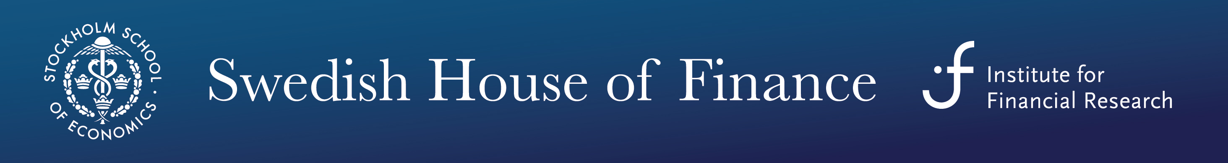
The Swedish House of Finance (SHoF) offers within its Doctoral Course Program in Finance a mini- course
Understanding Financial Regulation
with
Professor Amit Seru (Chicago Booth)

This course discusses the questions confronting academics and policymakers around the world in the area of regulation of financial intermediaries. I will start by discussing the background and genesis of the overall structure of financial regulation in the US (and Europe). I will then cover empirical work that has tried to explore the organization design of existing financial regulatory structure, i.e., the nature of regulatory rules as well as the regulatory structure. When discussing this work we will fall back on methods you have seen before in the basic empirical corporate class. The papers covered will form inferences based on methods such as difference-in-differences, regression discontinuity design and instrumental variables. We will conclude by open questions on the aspects of regulation design that need more (empirical) understanding.

Schedule
- Tuesday, October 8 2013, 10.00-12.00 & 14.00-16.00 at SHoF, Drottninggatan 98
- Wednesday, October 9 2013, 10.00-12.00 & 14.00-16.00, at SHoF, Drottninggatan 98
- Thursday, October 10 2013, 09.30-11.30 & 14.00-16.00, at SHoF, Drottninggatan 98

Registration
Please register in advance with the course secretary Jenny Wahlberg Andersson, Department of Finance, Stockholm School of Economics, Drottninggatan 98, 111 60 Stockholm, Phone: 736 9140, e-mail: jenny.wahlberg.andersson@hhs.se

Travel Stipends
SHoF offers travel stipends to PhD students from Swedish universities. To apply, please send a brief motivation letter/mail by the supervisor and a budget to jenny.wahlberg.andersson@hhs.se. The Nordic Finance Network (NFN) offers travel stipends to PhD students from other Nordic countries who come from one of the NFN member institutions. Information on how to apply for NFN travel stipends is on http://nfn.aalto.fi/courses.htm.

SHoF
On http://houseoffinance.se/phd-course-program/core-courses/ there is further information about SHoF’s Doctoral Course Program in Finance.

